**total amount of petrol in volume sold by every distributor:**

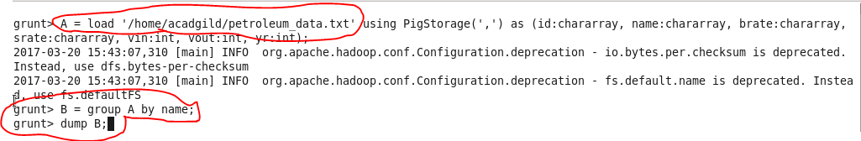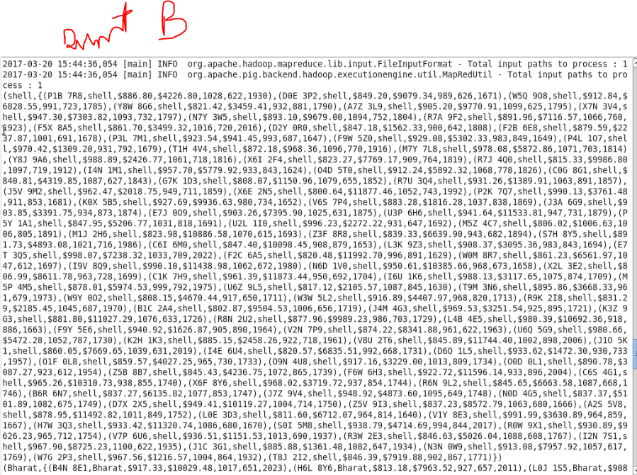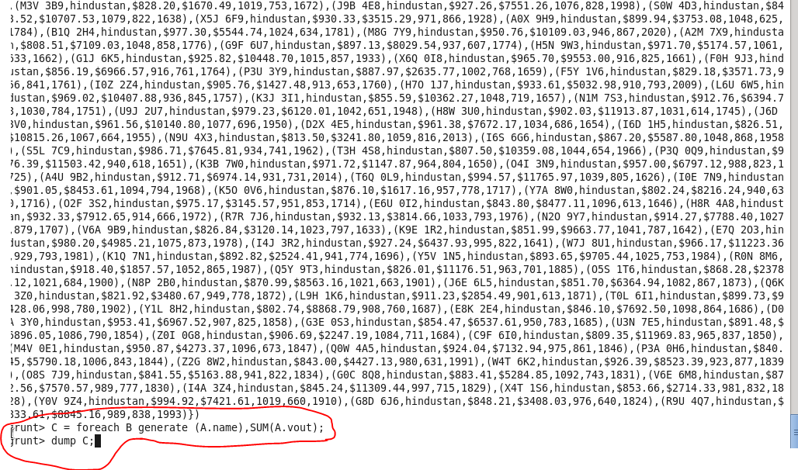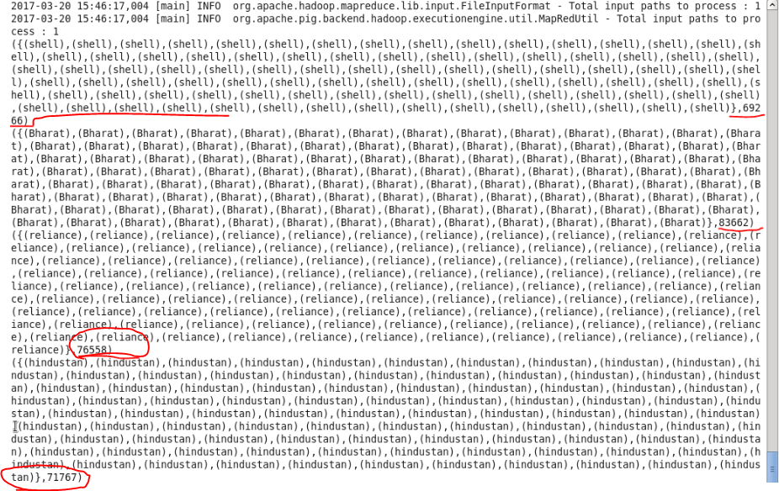

**the top 10 distributors ID's for selling petrol? Also display the amount of petrol sold in volume**

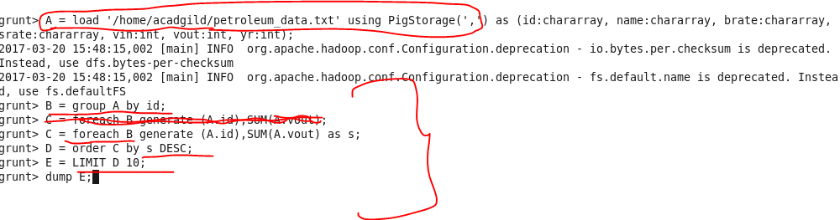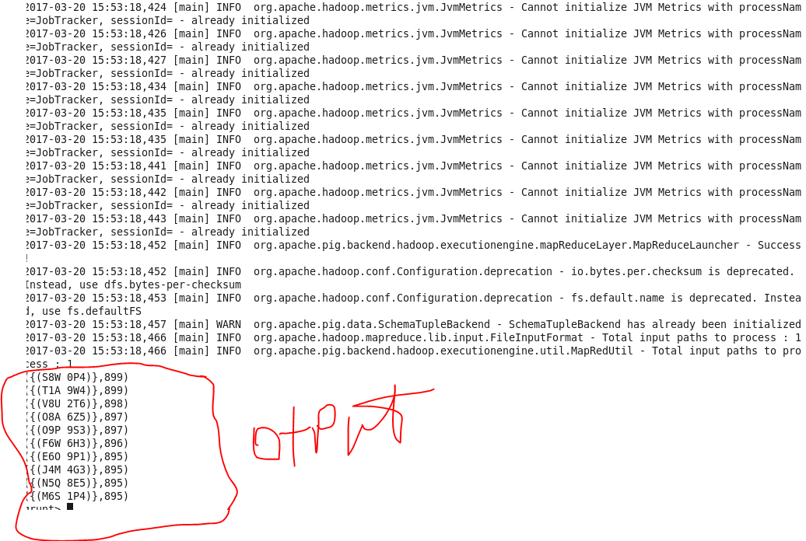

**List 10 years where consumption of petrol is more with the distributer id who sold it**

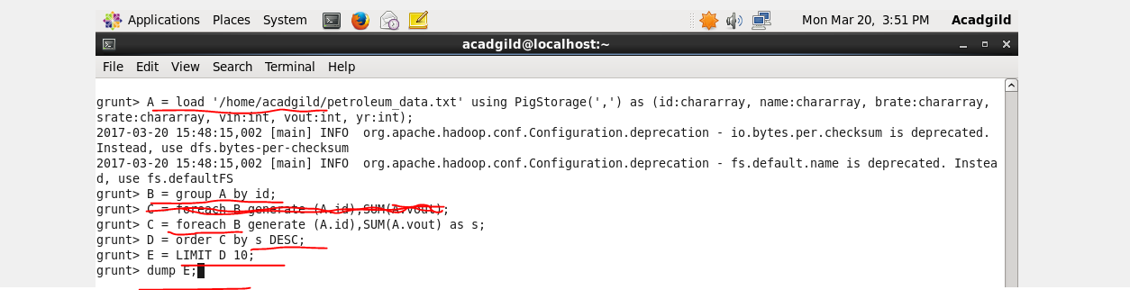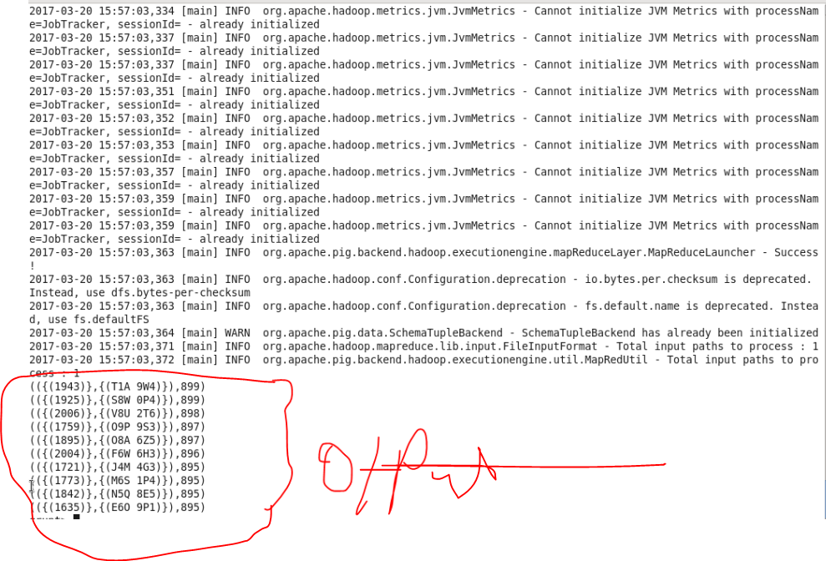

**distributer name who sold petrol in least amount**

